BMW Drivers Club Melbourne Inc

Annual General Meeting 2023 Proxy Voting form

This form must be signed and received by 7:30 pm October 11 2023

Proxy forms can be sent by mail to the PO Box shown below, or by email to secretary@bmwdcm.com.au.

I Member Number (if known) : ………………
(Name as shown on the membership register)

being a member with no break in membership of the BMW Drivers Club Melbourne Inc (the Club) in the 2 years ending in October 12 2023, hereby authorize

Member Number (if known) : …………………..
(Name as shown on the membership register – if left blank the Proxy will be the Club President as elected)

to be my proxy at the Club’s 2023 AGM and vote according to my instructions below in respect of confirming the minutes of the previous AGM (if present at the previous AGM) and Resolution 1 (shown overleaf) :

(Type Y in one box per row – “Proxy to decide” means the proxy will vote in a manner determined by the proxy. Otherwise you can direct how the proxy must vote)

Motion | Proxy to decide | For | Against | Was not present at previous AGM
That Minutes of the previous AGM be accepted

Motion | Proxy to decide | For | Against | Abstain
That Resolution 1 be accepted

Signed (Member) :

Date :

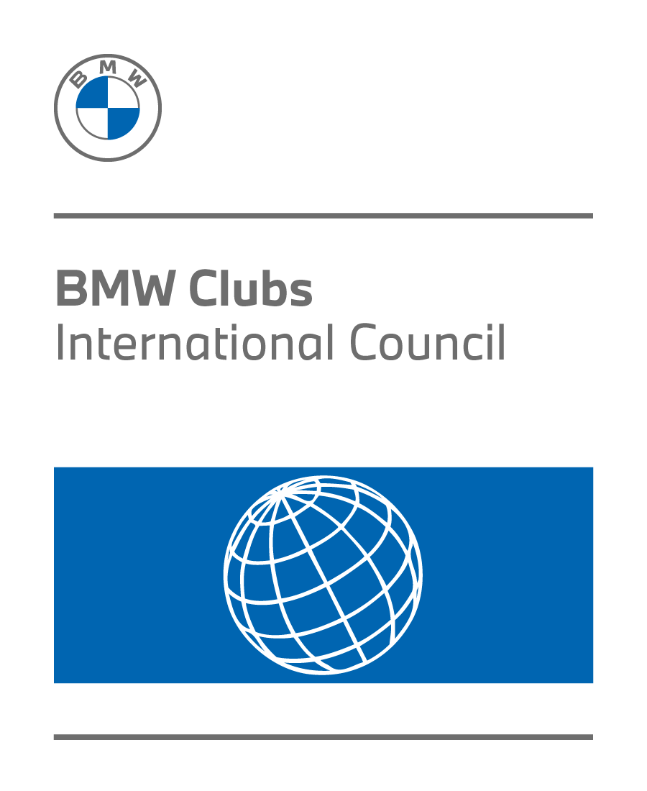
Resolution 1.

That for 20232/24 :
the Joining fee (applied to all classes except Additional Member, Junior Member, Honorary Member, Day Member and Life Member) will remain at $30;
the annual fee for Founding Member, Full Member, and Associate Member will remain at $60;
the annual fee for a 2nd or subsequent member at the same address will remain at $35;
the annual fee for a Junior Member will remain at $10;
the annual fee for a Honorary Member , Life member or Day member will remain at no charge.

