STONY CREEK KARTS – SUNDAY 16th AUGUST 2020 – ROUTE INSTRUCTIONS

Meet: 9.30am BP Roadhouse & MacDonalds, Caldermeade,
cnr South Gippsland Hwy (M420) & Caldermeade Road

Depart: 9.50am
Finish: 11.30pm Stony Creek Go-Karts Distance: 106 km
Duration: 1½ hours including one stop
SUMMARY

Caldermeade - Korumburra | 68 km | 60 min | Toilet stop
Korumburra – Stony Creek | 38 km | 35 min
ROUTE INSTRUCTIONS
km | Instruction | Notes
 | 1. Exit south-east on South Gippsland Hwy (M420)  and continue onto Bass Hwy (M420) | DO NOT turn left onto South Gippsland  Highway when it becomes A440
13.0 km | 2. Turn Left onto Gurdies-St Helier Road, signposted as such
9.3 km | 3. At T intersection at the Kernot Store, Turn Right onto Loch-Kernot Road
3.0 km | 4. At T intersection, Turn Left onto Grantville-Glen Alvie Road
4.9 km | 5. At apparent T intersection,  Turn Left then immediately Bear Right onto Glen Alvie Road (See map entering from top ➔ ) | 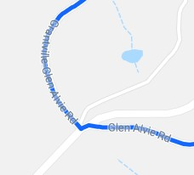
7.4 km | 6. Where road probably widens,  Turn Left onto Kongwak Road, signposted to Kongway etc | (Google street view has 2 different views of the intersection at different times)
3.8 km | 7. At roundabout, Turn Left onto Bena-Kongwak Road, signposted to Bena
17.5 km | 8. At T intersection, Turn Right onto Fullers Way,  signposted to Melbourne, Korumburra
1.1 km | 9. Go under the railway overpass, then at T intersection, Turn Right onto South Gippsland Hwy (A440), signposted to Leongatha
6.0 km | 10. In Korumburra, just after pedestrian crossing lights,  at Kelly’s Café, signposted to toilets,  Turn Left into carpark. | Toilet stop, view old railway station, coffee, etc
120m  30m | - Turn Left out of carpark to continue on our way, up towards the top of the hill.  - At the top of the hill, at BP service station, Turn Left onto Bridge Street,  signposted to Hospital, Burra Foods, etc  - Immediately Turn Right onto S Railway Crescent, signposted to Gooseneck Pottery etc. | 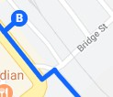  Don’t go over the railway line
6.3 km | 14. At X intersection, Turn Right onto One Chain Road | Road ahead is dirt, so don’t go there 😊
7.0 km | 15. After crossing railway line, at T intersection,  Turn Hard Left onto South Gippsland Hwy (A440),  signposted to Leongatha

km | Instruction | Notes
5.4 km  500m | - In Leongatha, dogleg right and left to continue on A440. What this looks like is:  Turn Right at T intersection, signposted B460 Inverloch Turn Left at Roundabout, signposted to A440 Foster  - Cross over railway line then follow main road to the Right to continue on South Gippsland Hwy (A440),  signposted to A440 Foster.  (Ignore the spurious Keep Left sign!!!) | 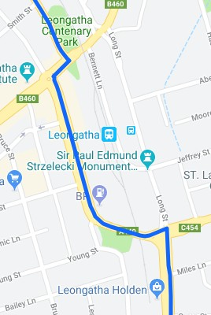
18.7 km | 18. Stony Creek Go Karts are on the right,  just before a horse racing track control tower. | Caution exiting 100km/h highway. Move quickly off the road to avoid  blocking following cars in our group
ROUTES TO HEAD HOME

All of these options are visible on the map on the next page.

- South Gippsland Highway (A440) – probably quickest and least interesting 😊
- My pick: Back to Korumburra, up the C425 to Ranceby (locale), left briefly onto the C432 then north on Main South Road (which, despite its name, is a little back road) through Poowong East to Drouin then to the M1 to Melbourne. Quite a direct route that’s probably the quickest one onto the M1. Keeps you out of the traffic, scenery is great and the roads are nice but not twisty.
- Back to Korumburra then north on the C425 to Warragul. Super scenic and a quite twisty, fun road but if you come across a slower car (likely) there are few overtaking places.
- C455 north to Mirboo North (murals to view, cafés, etc), then through Thorpdale to Trafalgar and take the M1 back to Melbourne. Scenic roads with a couple of nice, twisty sections.

ROUTE MAP

